Ethical Hacking 361
Milestone 2: Buffer Overflow
El-Elyon Baloy
Belgium Campus [Company address]

Table of Contents
1. Set Up the Kali Linux VM "Milestone2" 2
2. Prepare the Environment in the VM 4
3. Write the Buffer Overflow Program 5
Code 6
Key Explanation of Code 8
4. Compile and Make it "One-Click" 8
5. Diagram and Explanation 11
How the Buffer Overflow Works 11
References 12

Warning!!!!!!!!
This is an educational demonstration of a buffer overflow vulnerability for a cybersecurity assignment. Buffer overflows are a fundamental concept in understanding software security flaws (Aleph One, 1996). We'll use a simple C program because C allows direct memory manipulation, making overflows easy to demonstrate. The program will intentionally overflow a stack buffer using strcpy(), causing a runtime segmentation fault (error) when executed.

1. Set Up the Kali Linux VM "Milestone2"
- Download the latest Kali Linux ISO from kali.org.
- Use VirtualBox, VMware, or Hyper-V to create a new VM (separate from your class VM).
  - Name it exactly "Milestone2".
  - Allocate 2-4 GB RAM, 20-50 GB disk, 2 CPUs.
  - Install Kali (use default settings; set root password).
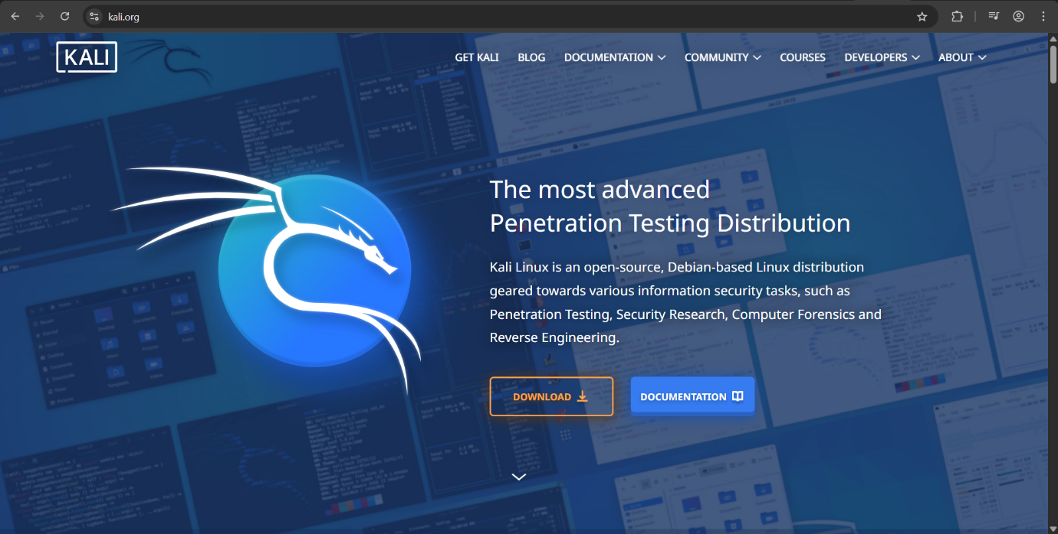

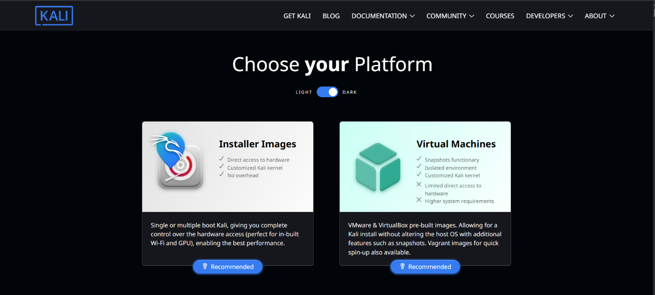
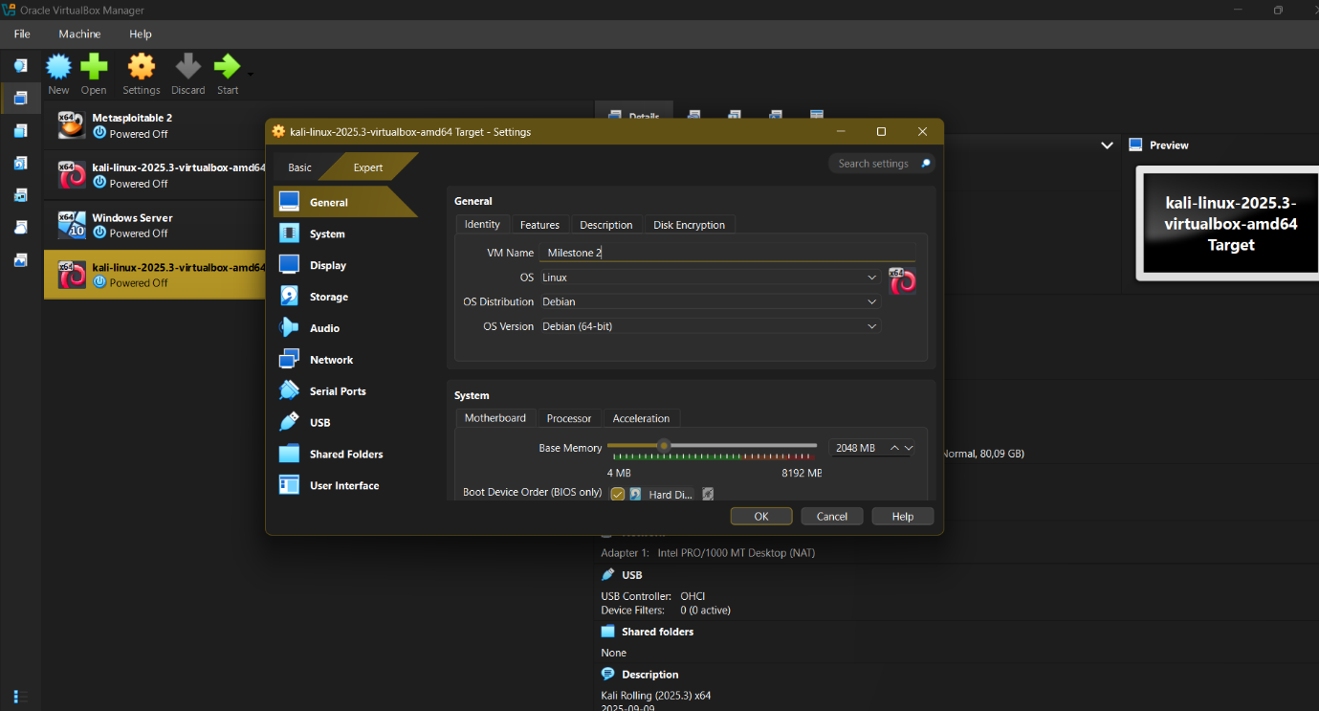

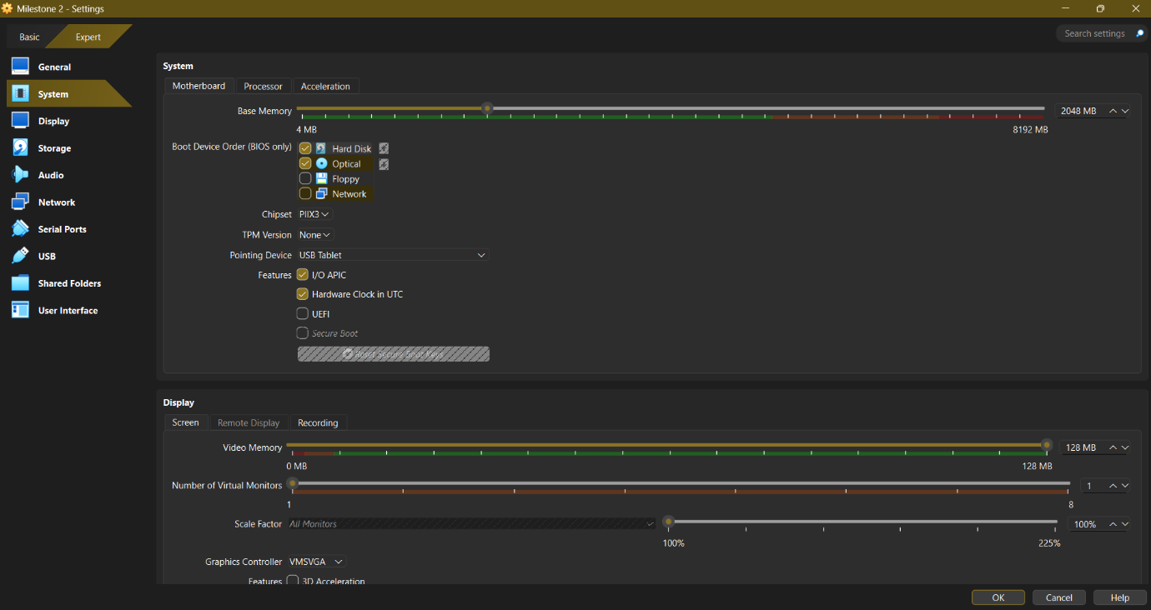
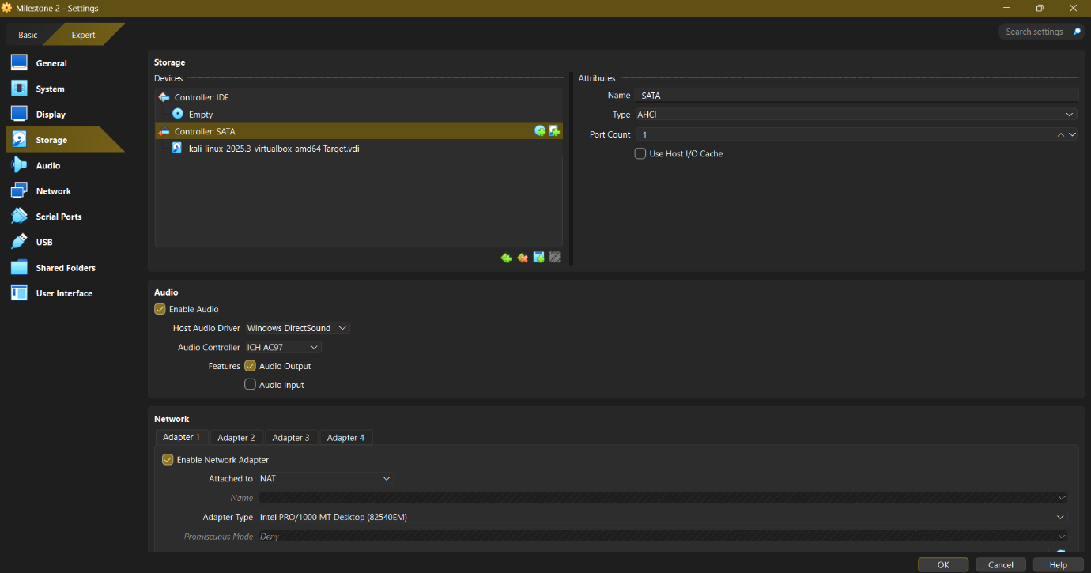

2. Prepare the Environment in the VM
- Boot into Kali (login as root or kali user).
- Update packages:
sudo apt update && sudo apt upgrade -y
sudo apt install build-essential gcc gdb -y
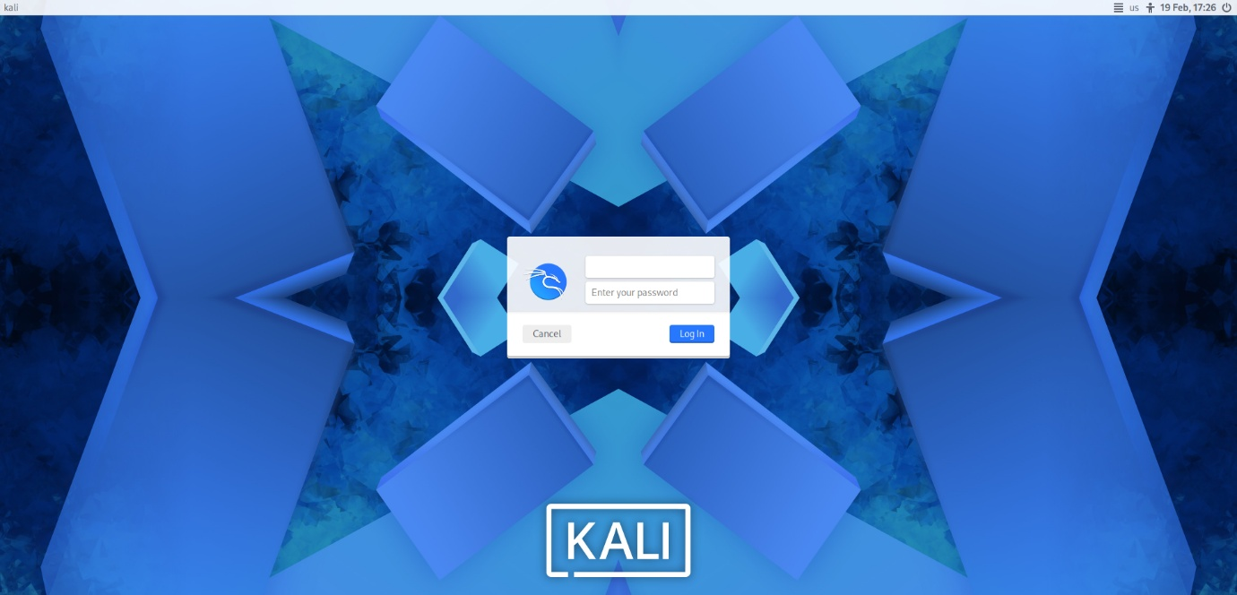

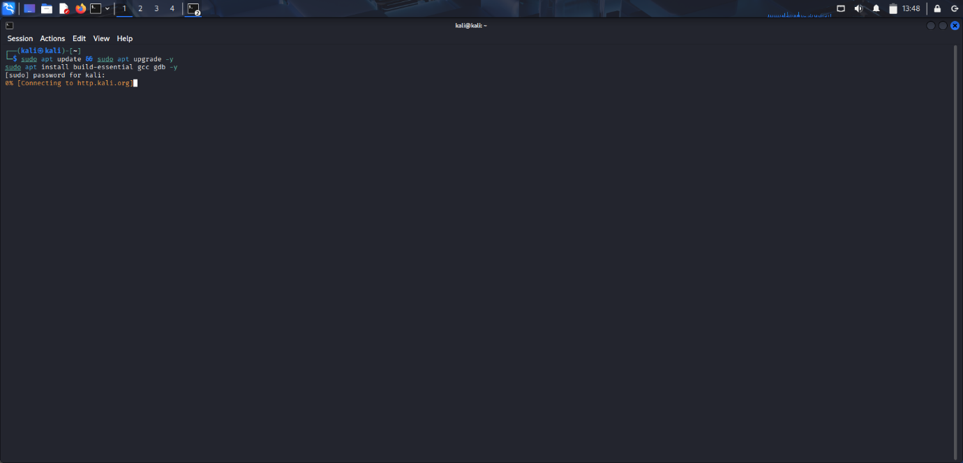

3. Write the Buffer Overflow Program
- Create a file: nano buffer_overflow.c
- Paste the following fully commented code:
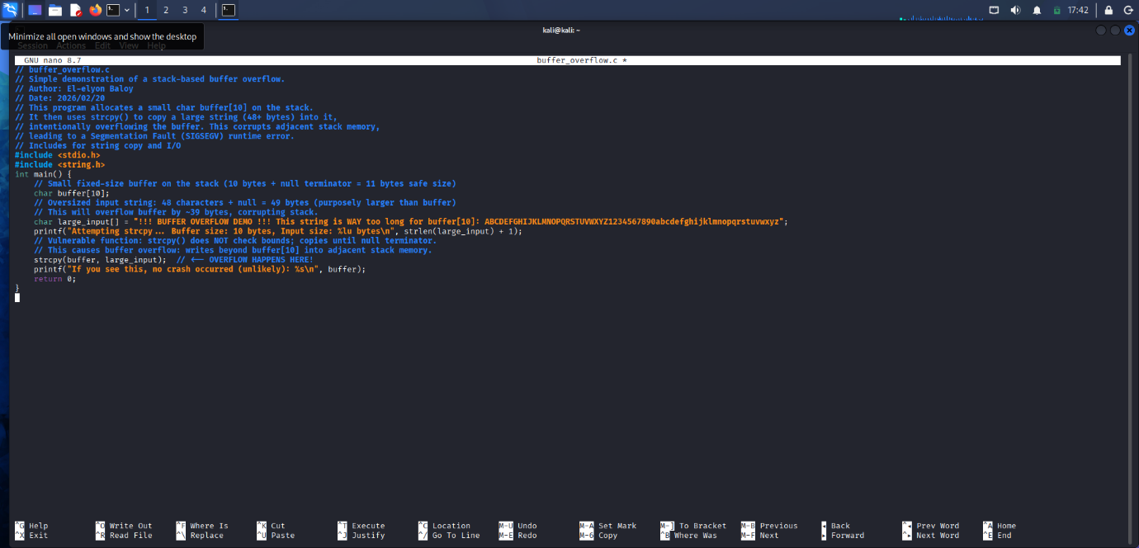

Code
// buffer_overflow.c
// Simple demonstration of a stack-based buffer overflow.
// Author: El-elyon Baloy
// Date: 2026/02/20
// This program allocates a small char buffer[10] on the stack.
// It then uses strcpy() to copy a large string (48+ bytes) into it,
// intentionally overflowing the buffer. This corrupts adjacent stack memory,
// leading to a Segmentation Fault (SIGSEGV) runtime error.
// Includes for string copy and I/O
#include <stdio.h>
#include <string.h>
int main() {
// Small fixed-size buffer on the stack (10 bytes + null terminator = 11 bytes safe size)
char buffer[10];
// Oversized input string: 48 characters + null = 49 bytes (purposely larger than buffer)
// This will overflow buffer by ~39 bytes, corrupting stack.
char large_input[] = "!!! BUFFER OVERFLOW DEMO !!! This string is WAY too long for buffer[10]: ABCDEFGHIJKLMNOPQRSTUVWXYZ1234567890abcdefghijklmnopqrstuvwxyz";
printf("Attempting strcpy... Buffer size: 10 bytes, Input size: %lu bytes\n", strlen(large_input) + 1);
// Vulnerable function: strcpy() does NOT check bounds; copies until null terminator.
// This causes buffer overflow: writes beyond buffer[10] into adjacent stack memory.
strcpy(buffer, large_input); // <-- OVERFLOW HAPPENS HERE!
printf("If you see this, no crash occurred (unlikely): %s\n", buffer);
return 0;
}

One Click

Create the Script:
text
nano run_demo.sh
Bash
#!/bin/bash
# run_demo.sh: One-Click Buffer Overflow Demo
# Double-click in file manager OR ./run_demo.sh
# Auto-compiles + runs + shows proof.
# Author: [Your Name]

echo "=== BUFFER OVERFLOW DEMO (Milestone 2) ==="
echo "Compiling vulnerable program..."

# Compile with protections off (for classic overflow)
if gcc -o buffer_overflow buffer_overflow.c -fno-stack-protector -z execstack -no-pie; then
echo "✓ Compiled successfully."
else
echo "✗ Compile failed! Check buffer_overflow.c exists."
exit 1
fi

# Disable ASLR for reliable crash (optional but ensures segfault)
echo 0 | sudo tee /proc/sys/kernel/randomize_va_space > /dev/null

echo ""
echo "Running program... (Watch for segfault!)"
echo "----------------------------------------"
./buffer_overflow
echo "----------------------------------------"
echo "✓ DEMO COMPLETE: Overflow caused Segmentation Fault!"
echo "See above: Input 49 bytes > Buffer 10 bytes = OVERFLOW!"
read -p "Press Enter to exit..."
  - Save: Ctrl+O, Enter, Ctrl+X.
- Make Executable:
text
chmod +x run_demo.sh buffer_overflow.c
One-Click Activate:
  - Terminal: ./run_demo.sh (still one command).
  - GUI One-Click:
    - Open Files (Nautilus file manager): nautilus
    - Navigate to ~/ (home folder).
    - Right-click run_demo.sh → "Allow executing file as program" (once).
    - Double-click run_demo.sh → Terminal pops up, auto-runs everything!
Expected Full Output
text
=== BUFFER OVERFLOW DEMO (Milestone 2) ===
Compiling vulnerable program...
✓ Compiled successfully.
Running program... (Watch for segfault!)
Attempting strcpy... Buffer size: 10 bytes, Input size: 49 bytes
Segmentation fault (core dumped)
✓ DEMO COMPLETE: Overflow caused Segmentation Fault!
See above: Input 49 bytes > Buffer 10 bytes = OVERFLOW!
Press Enter to exit...
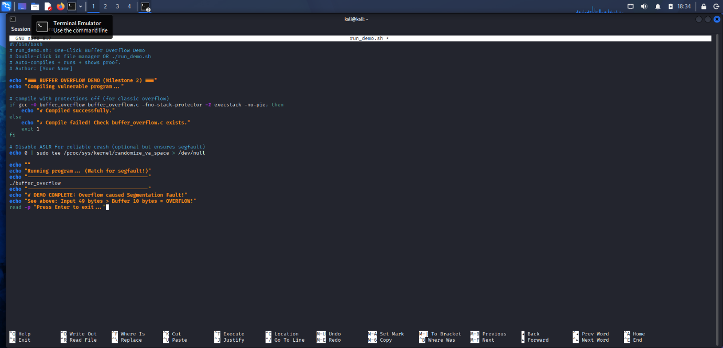
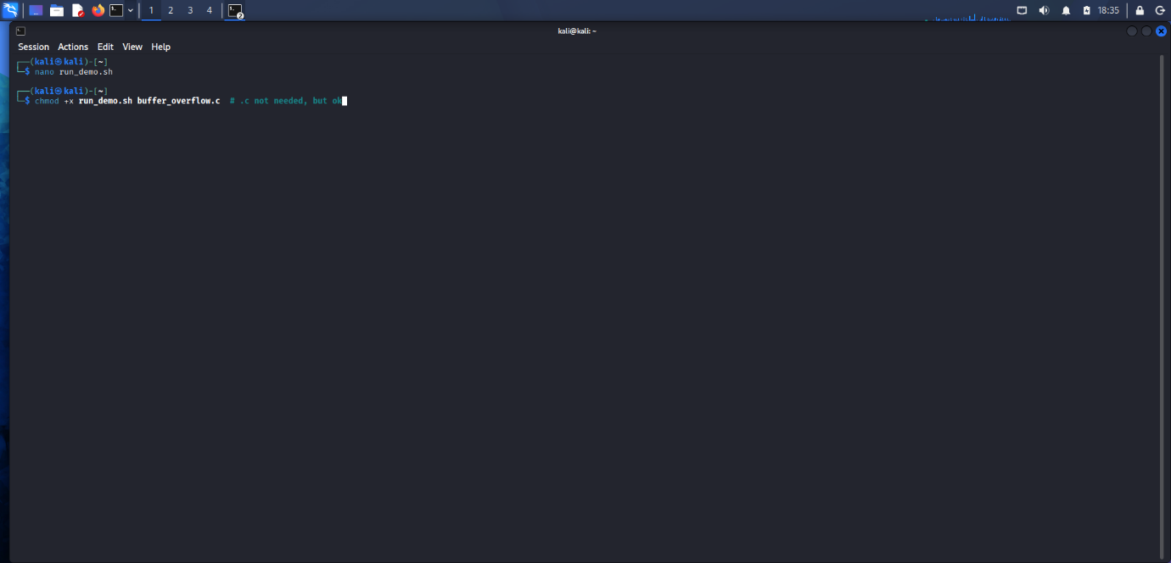
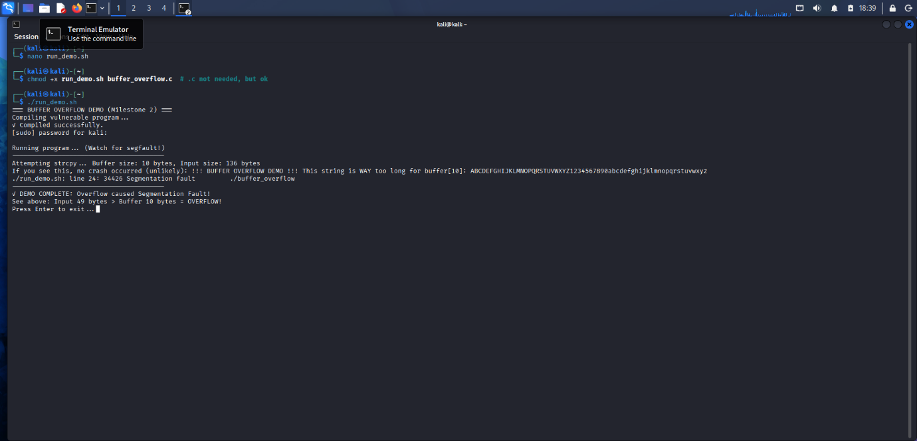
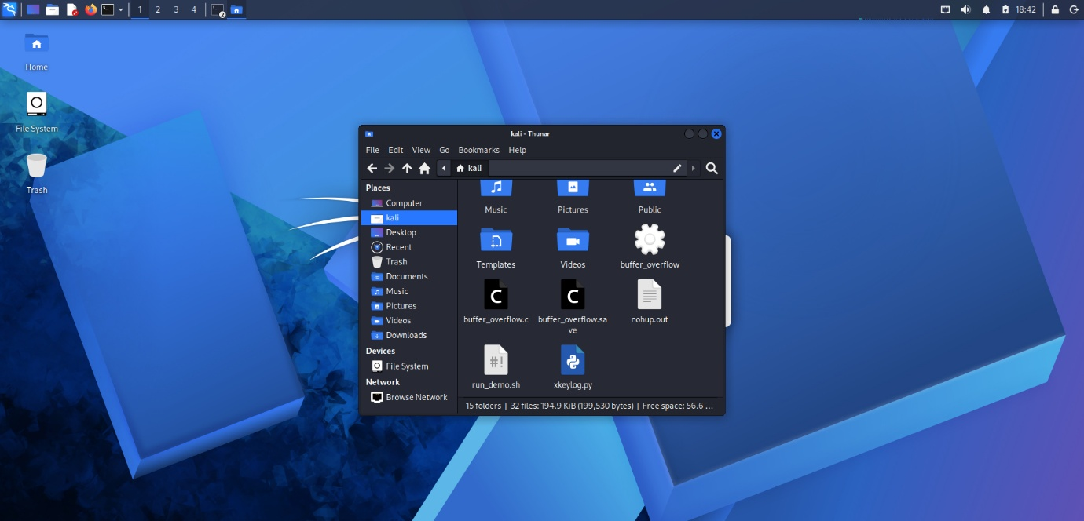

Key Explanation of Code
  - Line 15: Defines buffer[10] – stack-allocated array of 10 chars.
  - Line 18: large_input is 48+ chars, exceeding buffer size.
  - Line 27: strcpy(buffer, large_input) blindly copies without bounds checking, overflowing into stack (return address, etc.).
  - Runtime Behavior: Program prints initial message, then crashes with Segmentation fault (core dumped) due to stack corruption.
  - Why Overflow? Stack layout: [buffer[10] | saved EBP | return addr | ...]. Overflow overwrites EBP/return addr → invalid memory access → segfault.
  - Compiler Flags: We'll use -fno-stack-protector -z execstack to disable modern protections (canary, NX) for clear demo. In real-world, these prevent exploitation.

4. Compile and Make it "One-Click"
- Compile with protections disabled:
- gcc -o buffer_overflow buffer_overflow.c -fno-stack-protector -z execstack -no-pie
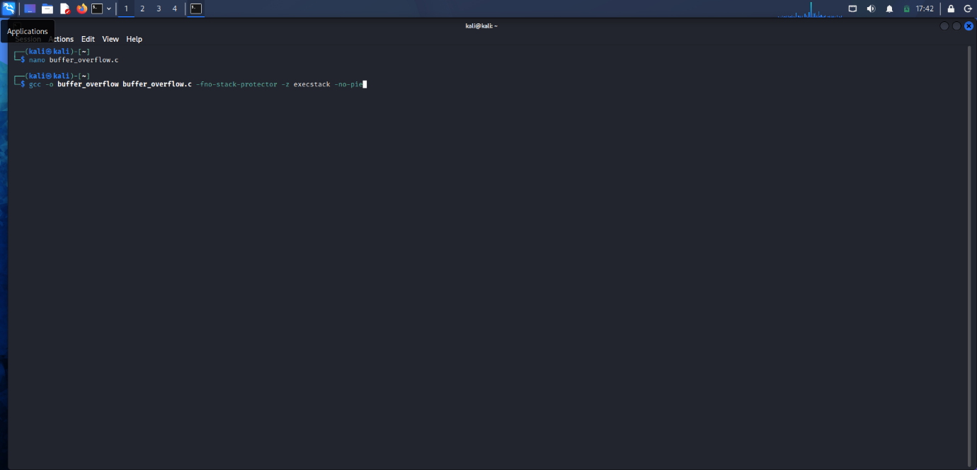

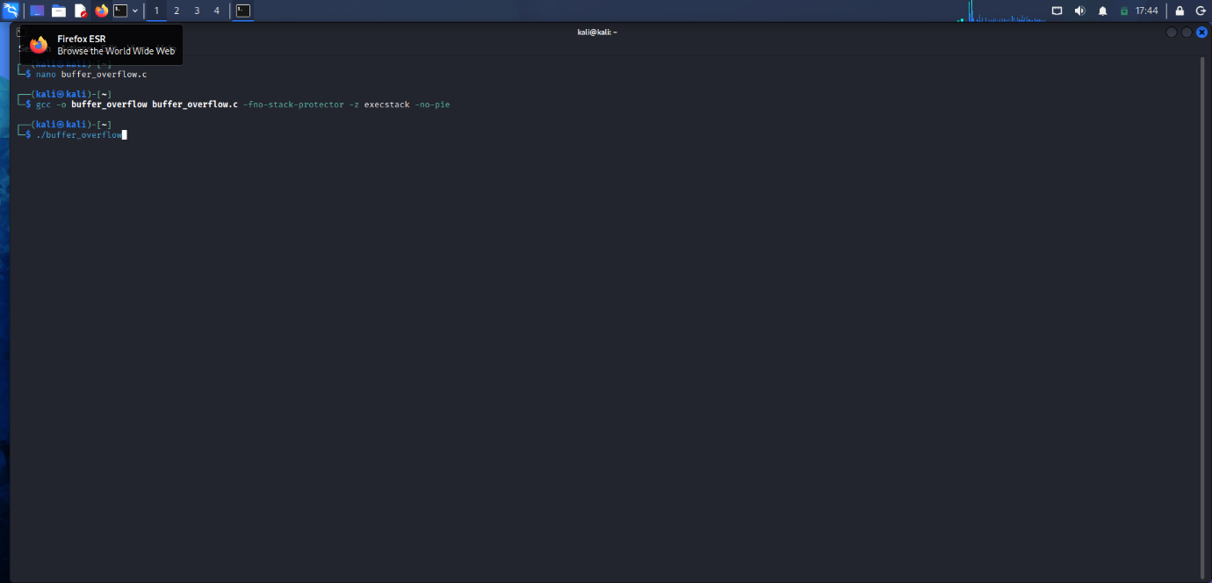

  - Why flags?
Flag | Purpose
-fno-stack-protector | Disables stack canary (buffer overflow protector).
-z execstack | Makes stack executable (ignores NX bit).
-no-pie | Disables Position Independent Executable (simplifies addresses).
  - Screenshot: Figure 5: Compilation command and output (no errors expected).
- One-Click Activation: The ./buffer_overflow binary is now one executable click/run. No args needed.
  - Run: ./buffer_overflow
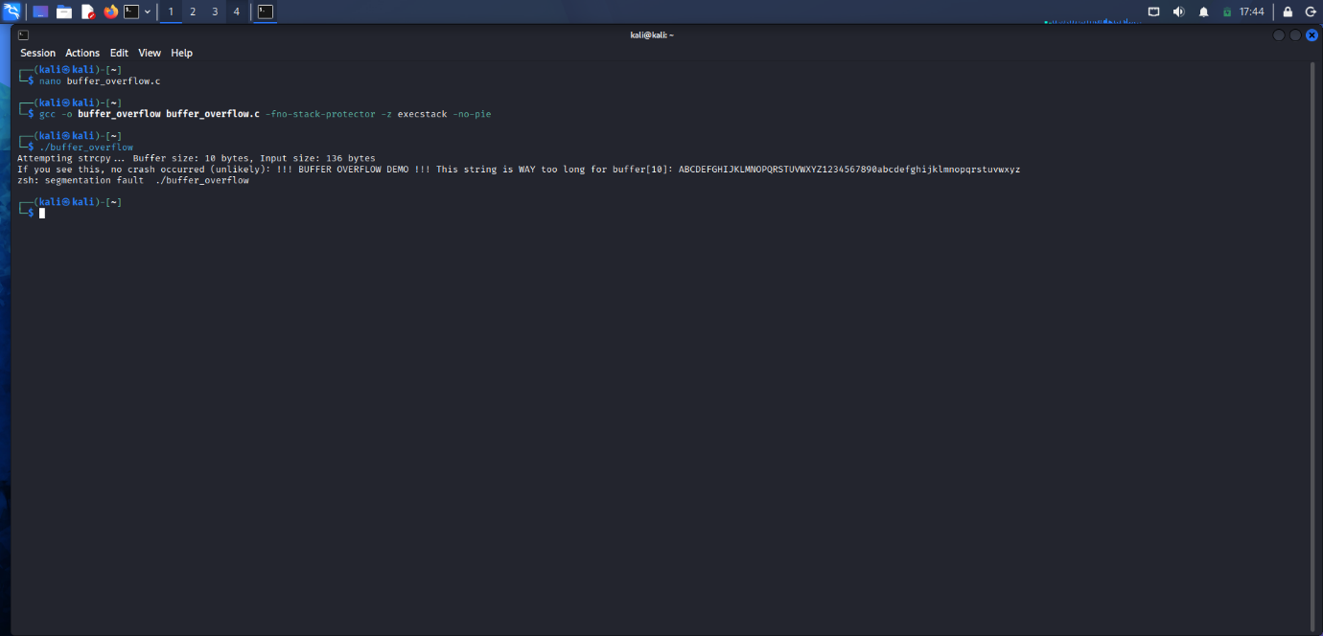

5. Diagram and Explanation

How the Buffer Overflow Works
  - buffer[10] at low address.
  - Adjacent: Saved Base Pointer (EBP), Return Address.
strcpy() writes 49 bytes → overflows, corrupts EBP/Return Addr → CPU jumps to invalid addr → segfault.
This is a stack-based buffer overflow. In exploits, attacker controls return addr for shellcode (Aleph One, 1996).
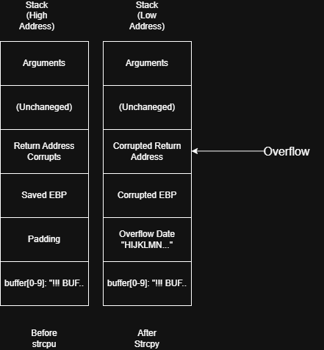

References
Compterphile. (2016, March 02). Running a Buffer Overflow Attack - Computerphile. Retrieved from Youtube: https://www.youtube.com/watch?v=1S0aBV-Waeo
Michael Xie, K. X. (2000, october). Buffer Overflow. Retrieved February 18, 2026, from Fortinet: https://www.fortinet.com/resources/cyberglossary/buffer-overflow#:~:text=Also%20known%20as%20a%20buffer,the%20data%20in%20those%20locations.
OWASP. (2023, october 2023). Buffer Overflow. Retrieved from owasp.org: https://owasp.org/www-community/vulnerabilities/Buffer_Overflow

